**AI-POWERED NUTRITION ANALYZER FOR FITNESS ENTHUSIASTS**

**ABSTRACT**

As the world grows more fitness-conscious with passing time, the demand for technological solutions to cater to this burgeoning demand is diversifying. In India, this global trend has had a positive impact on scores of startups and websites catering to this segment. AI and its various subsets have been leveraged by these platforms to identify the calorie intake and also to make food recommendations for a healthy diet. In most cases, what we see is that these platforms act as a data repository where while providing real-time information to its users, it also makes available to numerous clients who work in this field for a determined rate. In this article, we take a look at the top AI-based online platforms which make use of AI and other deep learning technologies to provide a real-time updates about nutrition intake. The main aim of the project is to building a model which is used for classifying the fruit depends on the different characteristics like color, shape.

FEATURE EXTRACTION:

Pixel:

The most naïve way of choosing features from images is by their raw pixels. Indeed, it did not give much info on the characteristics of a particular food. Having varying sizes and resolutions in input images required uniform resizing for pixel feature extraction. However, reducing the image size may cause images to lose important detail that might be crucial for classification. The results of using pixels as the features can be seen in Section 5.1.1 Pixel Features Evaluation.

Edge Detection

Instead of using raw pixels as features for images, I thought that edges would be more representative of what the object is. My hypothesis was that objects in the same class tend to have similar edges. As for implementation, I have applied three most widely used edge detection methods (Sobel, Canny, Prewitt) as feature extractors over all the images in each class. Different edge detectors produced different edges which can be viewed in Figure 1. The output of the edge function is logical 1’s and 0’s, therefore, this feature extraction method does not provide lots of detail of the image for further processing. Each edge detection method has advantages and disadvantage over the other. The results of using edge detection as the feature extractor is shown in Section 5.1.2 Edge Detectors Evaluation.

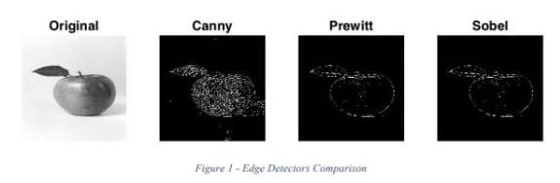

**NUTRITION ANALYSIS:**

Food is essential for human life and has been the concern of many healthcare conventions. Nowadays new dietary assessment and nutrition analysis tools enable more opportunities to help people understand their daily eating habits, exploring nutrition patterns and maintain a healthy diet. It is vital part of analytical chemistry that provides information about the chemical composition, processing quality control and contamination of food. Here the user can capture the image will be sent the trained model. The model analyses the image and detect the nutrition based on fruits like (sugar, Protein, Calories, etc.).

**TECHNICAL ARCHITECTURE:**

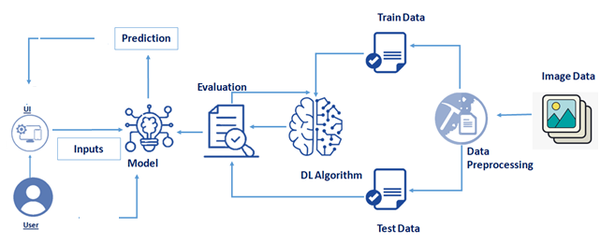

**BITE AI:**

The machine learning facilities provisions like recognition of past meals, make hierarchical prediction that is detect high level categories like beverages and soup as well as specific dished and ingredients. It also integrates with their food knowledge graph that contains a large set of commonly eaten foods with nutrition facts, and hierarchical structure. The platform also further breaks down the nutrition calories, macro and micronutrients as well as ingredient. Is yet another online platform which uses deep learning and image recognition to analysis what the users eat and determine what is trending in terms of each popular dish and consumption time.

**CONCLUSION:**

Thus powered nutrition analyzer for fitness enthusiasts good nutrition promotes not only better physical healthy and reduced susceptibility to disease, but has also been demonstrated to contribute to cognitive development and academic success. Left to their own devices, children will not automatically select healthy food. A balance diet and appropriate meal timings are important for healthy body and mind. Most countries nowadays implement health education programme in schools which include feeding to students, vitamin and mineral supplementation.

**REFERENCE:**

1. Published on April 8, 2019 From Gynaecology to Data Science : The journey of Dr Nitin Paranjape. Analyticsindiamag.com, Akshaya Asokan.
2. Melina cote and Benoit Lamarche , Applied Physiology , Nutrition and Metabolism 15
3. Deloitte(2017) the hospital of the future URL www.deloitte.com/us/global-hospital-of-the future (accessed August 9,2019)
4. INQA (Ed.)(2015) intelligente technik in der beruflichen pfege.von den chance und Risiken einer Pflege 4.0.
5. McCarthy, J., Minsky, M. L., Rochester, N., & Shannon, C. E. (2006). A Proposal for Dartmouth Summer Research Project on Artificial Intelligence. AI Magazine, 27(4), 12-14. https://www.aaai.org/ojs/index.php/aimagazine/ article/view/1904/1802.
6. Lalwani, P.(2019). The ethics of AI in HR : what does it take to build an ai ethics framework? https://www.hrtechnoologist.com/articles/digital-transformation/the-ethics-of-ai-in-hr/
7. Kozan, K.(2017), 3 simple step for improving your candidate engagement, https://ideal.com/candidate-engagement.